Pizza Sales SQL Queries
KPIs
1. Total Revenue
Query : SELECT SUM(total_price) AS Total_Revenue FROM pizza_sales;
Result :
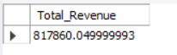

2. Average Order Value
Query : SELECT SUM(total price)/COUNT(DISTINCT order_id) AS Avg_order_value
FROM pizza_sales;
Result :
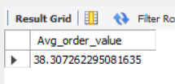
3. Total Pizza Sold
Query : SELECT SUM(quantity) AS Total_Pizza_Sold FROM pizza_sales;
Result :
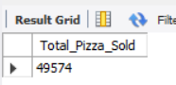
4. Total Orders
Query : SELECT COUNT(DISTINCT order_id) AS Total_Orders FROM pizza_sales;
Result :
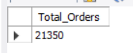

5. Average Pizza Per Order
Query : SELECT ROUND(SUM(quantity)/COUNT(DISTINCT order_id),2) AS Avg_Pizza_Per_Order FROM pizza_sales;
Result:
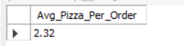

Daily Trend For Total Orders
Query : SELECT DAYNAME(order_date) AS Order_day,
COUNT(DISTINCT order_id) as Num_of_Orders
FROM pizza_sales
GROUP BY Order_day
ORDER BY Num_of_Orders DESC;
Result :
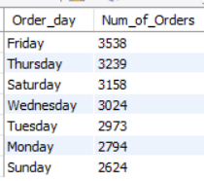

Hourly Trend For Total Orders
Query : ELECT HOUR(order_time) AS Order_Hour,
COUNT(DISTINCT order_id) AS Num_of_Orders
FROM pizza_sales
GROUP BY Order_Hour;

Result :
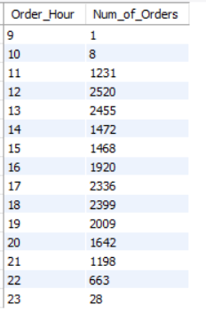

% Of Sales By Pizza Category
Query : SELECT pizza_category,ROUND(SUM(total_price)/
(SELECT SUM(total_price) FROM pizza_sales)*100,2) AS Total_Sales_Percentage
FROM pizza_sales
GROUP BY pizza_category
ORDER BY Total_Sales_Percentage DESC;
Result :
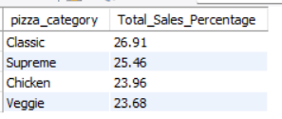

% Of Sales By Pizza Size
Query : SELECT pizza_size, ROUND(SUM(total_price)/
(SELECT SUM(total_price) FROM pizza_sales)*100,2) as Sales_Percentage
FROM pizza_sales
GROUP BY pizza_size
ORDER BY Sales_Percentage DESC;
Result :
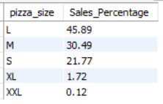
Total Pizzas Sold by Pizza Category
Query : SELECT pizza_category,SUM(quantity) AS Total_Pizza_Sold
FROM pizza_sales
GROUP BY pizza_category
ORDER BY 2 DESC;
Result :
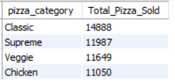
Top 5 Best Sellers
Query : SELECT pizza_name, SUM(quantity) AS Quantity_Sold
FROM pizza_sales
GROUP BY pizza_name
ORDER BY Quantity_Sold DESC
LIMIT 5;
Result :
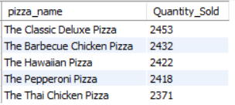
Bottom 5 Worst Sellers
Query : SELECT pizza_name, SUM(quantity) AS Quantity_Sold
FROM pizza_sales
GROUP BY pizza_name
ORDER BY Quantity_Sold
LIMIT 5;
Result :
